Spring Boot Authentication by JWT

Use Postman for the process

Help taken from - <https://dzone.com/articles/spring-boot-security-json-web-tokenjwt-hello-world>

Run Application By:

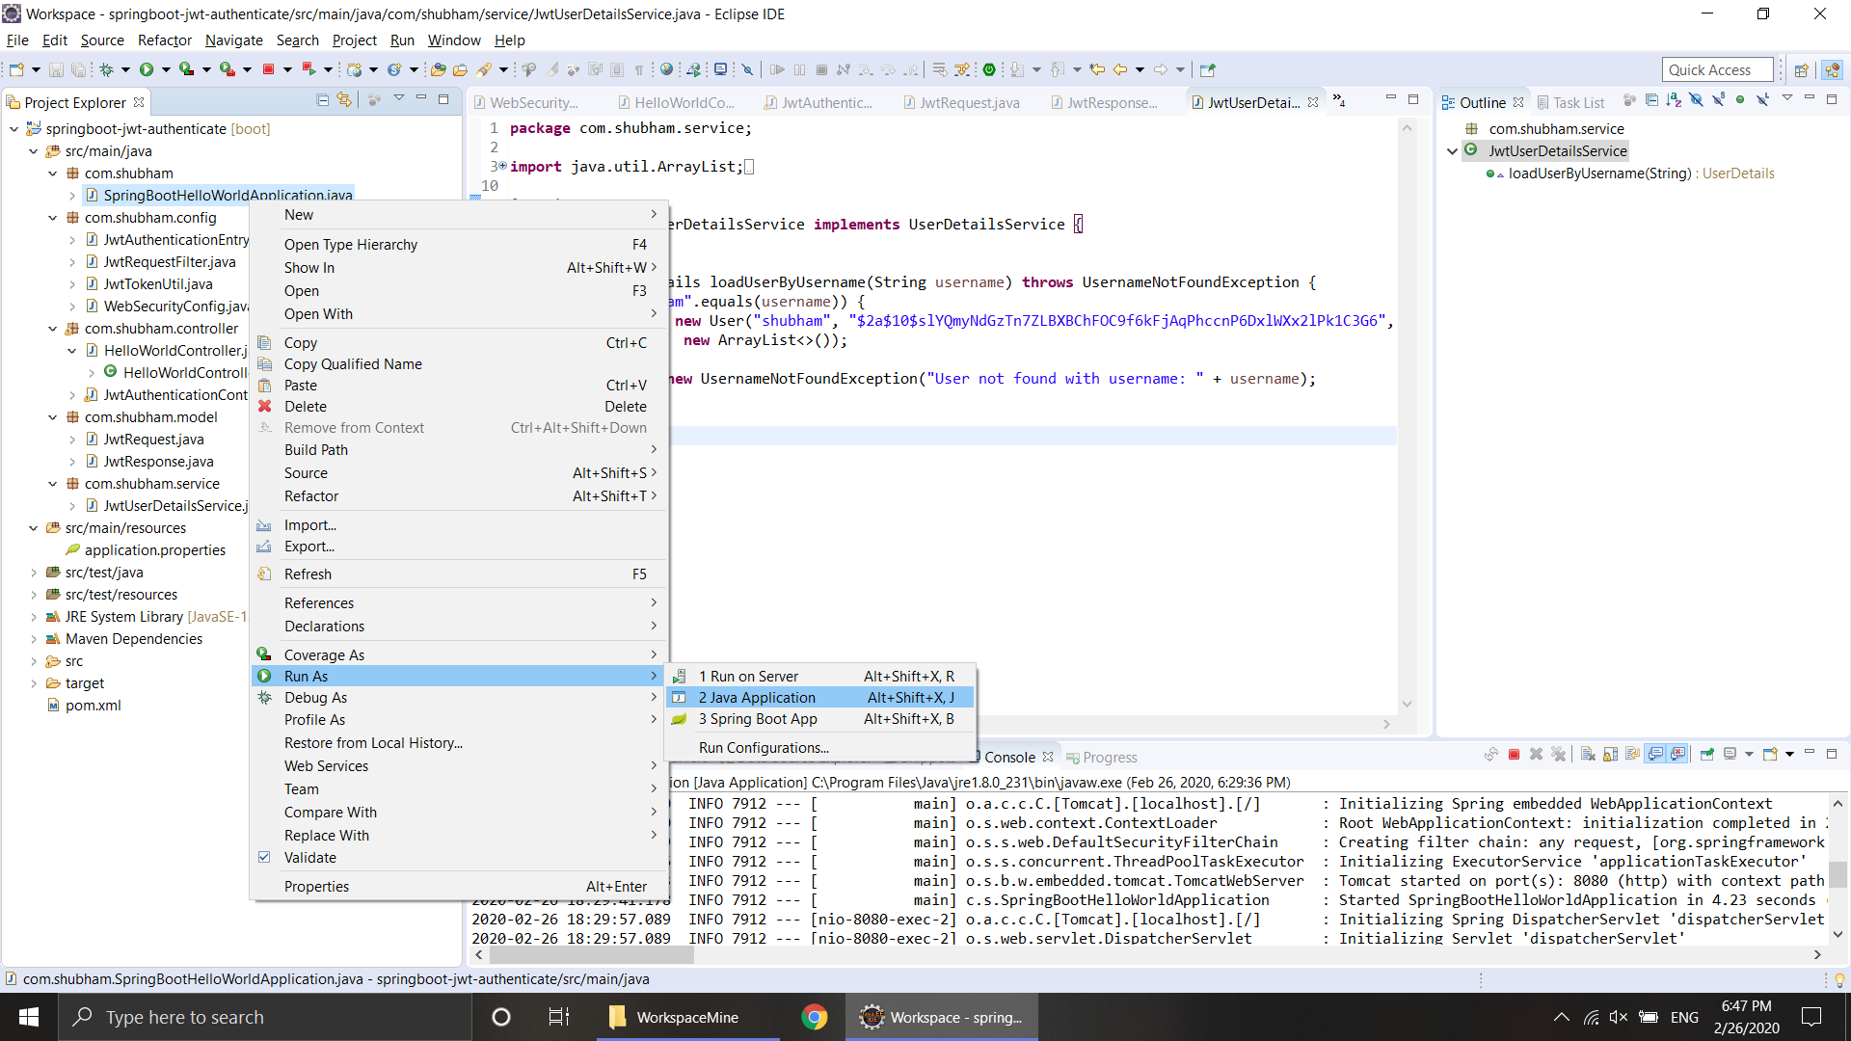

1. If you access <http://localhost:8080/hello> at first without authentication, it will give: 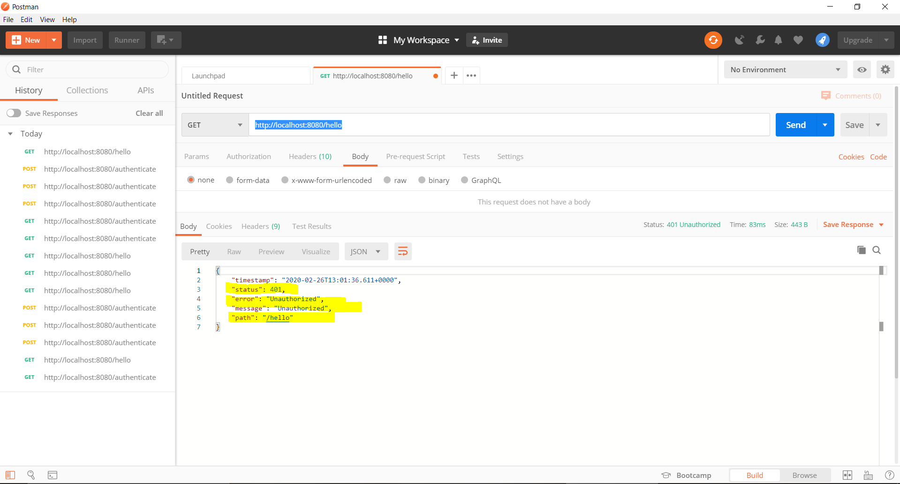
2. So, first <http://localhost:8080/authenticate> using post as option: token is generated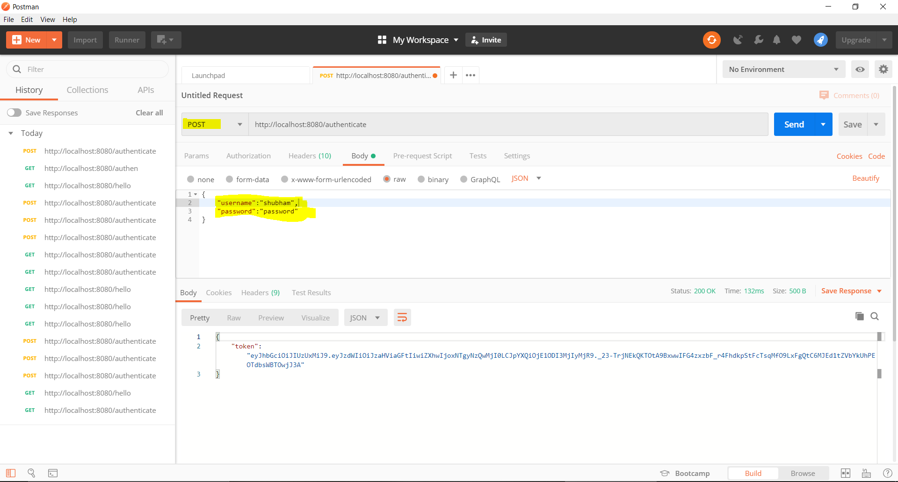
3. Copy the token, put request as GET, access <http://localhost:8080/hello> and put Authentication and Bearer <space> copied token as value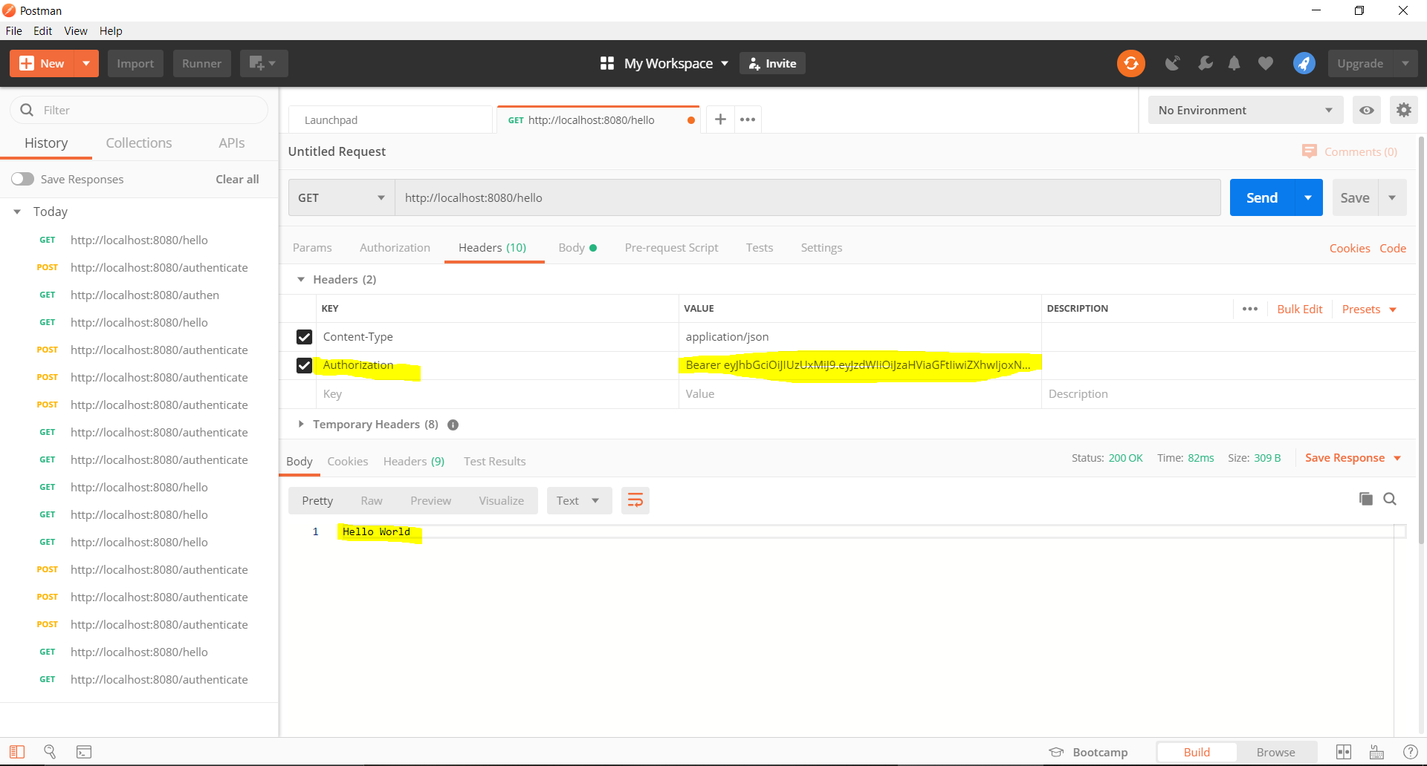

Test Cases:

1. If password is wrong: 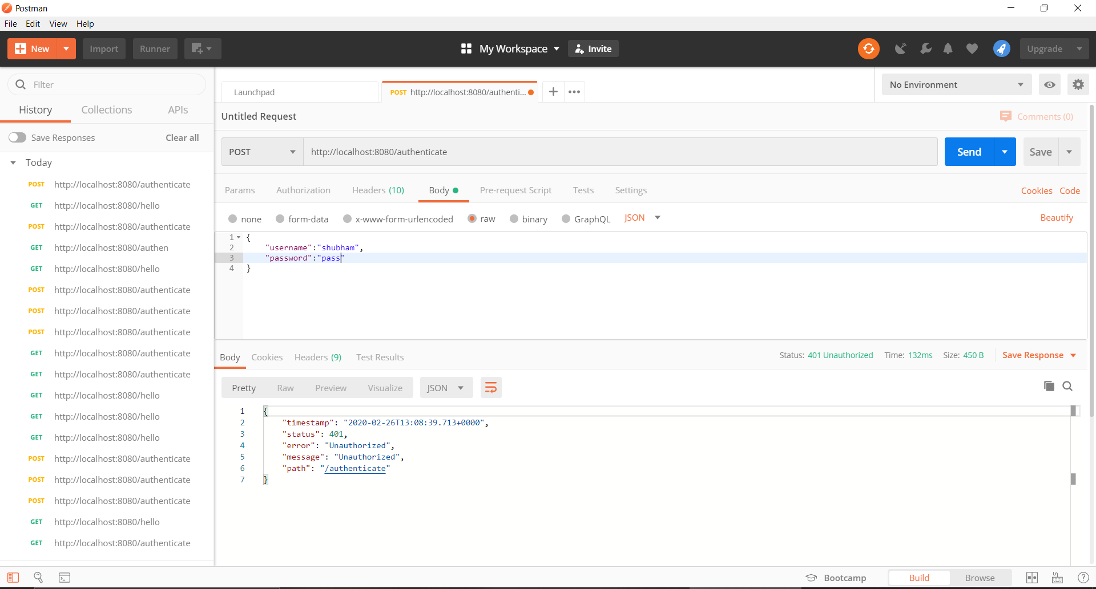
2. If GET method used: 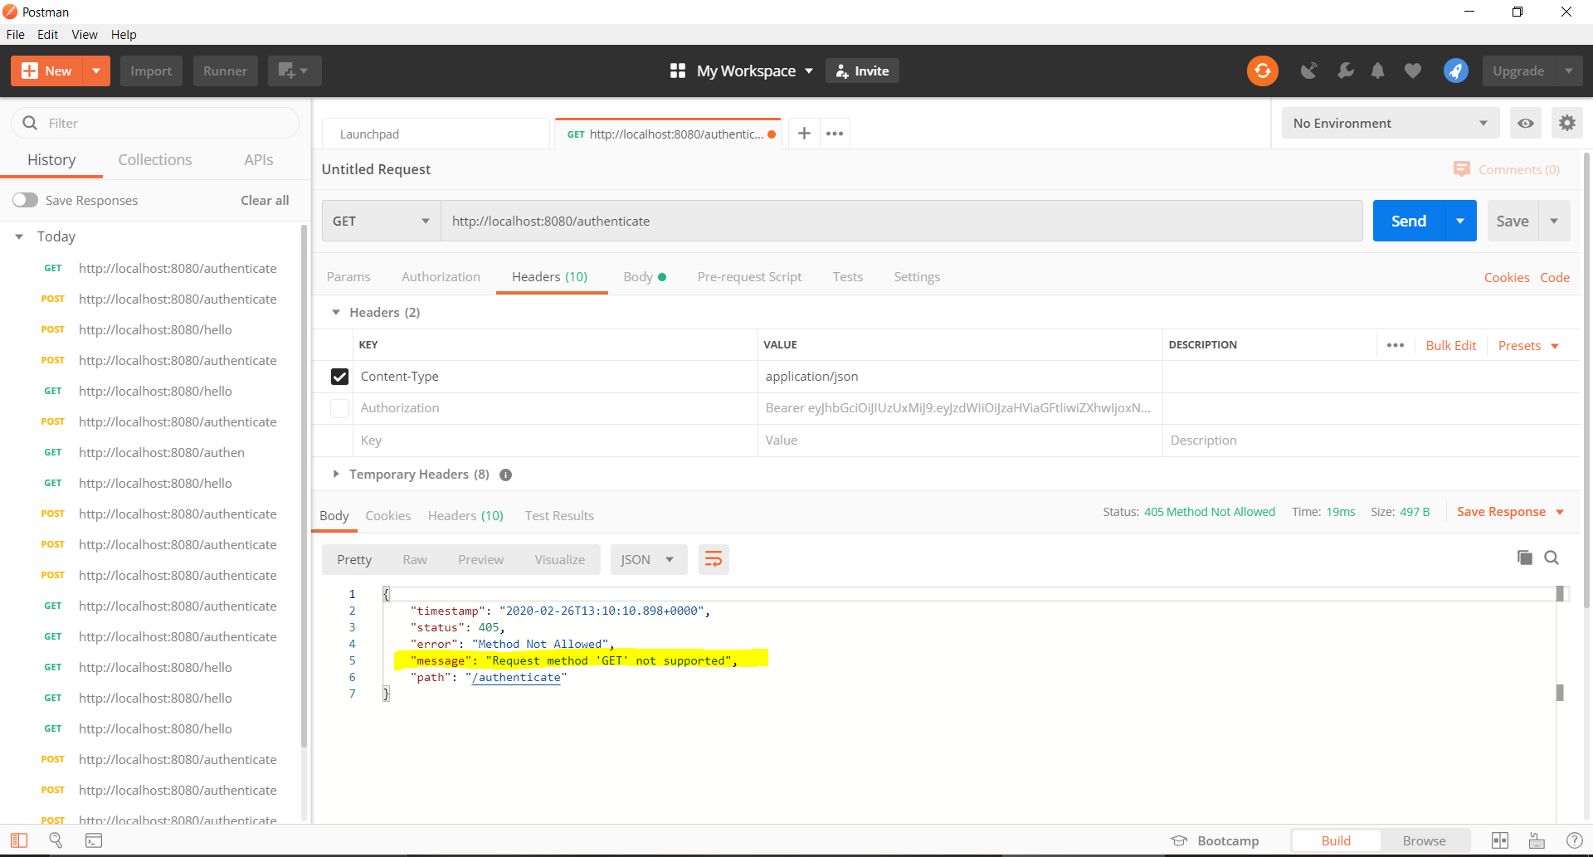
3. If Bearer word not used: 